CAMBRIDGE LINKS FOR LICEO SITE

https://www.youtube.com/watch?v=UAehOcVfr3Y

LINK FOR IELTS

https://www.youtube.com/watch?v=2h1siL8CTyM

COMMON REFERENCE LEVELS

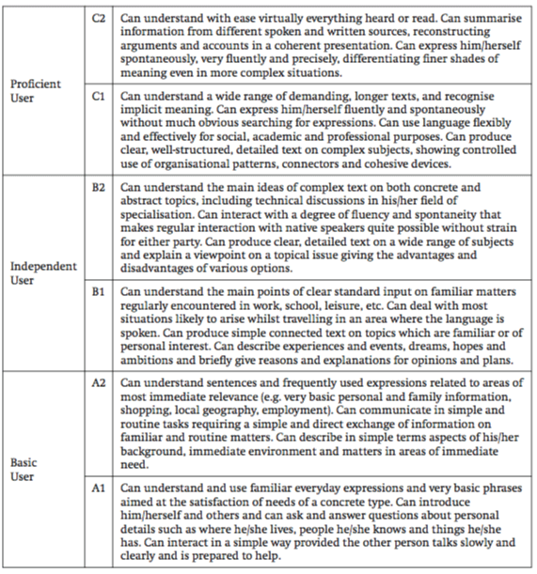
All exams by Cambridge on CEFR

